Predicate Nominative

✅ What Is a Predicate Nominative?
# Source: AI Source: Provided by: [Data Path: Persons Table -> ID Column: 1, Name_En Column: Motasem Essam] -> From: [ChatGPT] on [8/4/2025]
A Predicate Nominative (also called a predicate noun or subject complement) is a noun or pronoun that follows a linking verb and renames or identifies the subject of the sentence.
It is a subtype of the Nominal Predicate, where the verb doesn’t show action but instead links the subject to a noun/pronoun that gives it another name.

🔸 Key Features:
# Source: AI Source: Provided by: [Data Path: Persons Table -> ID Column: 1, Name_En Column: Motasem Essam] -> From: [ChatGPT] on [8/4/2025]
- Always follows a linking verb (e.g., is, was, are, become, seem).
- Renames the subject.
- Functions grammatically as a noun or pronoun.
- Subject and predicate nominative are typically interchangeable in meaning.

🔸 Examples:
# Source: AI Source: Provided by: [Data Path: Persons Table -> ID Column: 1, Name_En Column: Motasem Essam] -> From: [ChatGPT] on [8/4/2025]
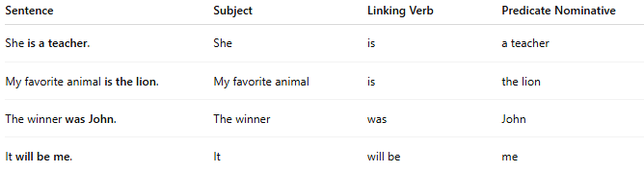
Sentence | Subject | Linking Verb | Predicate Nominative
She is a teacher. | She | is | a teacher
My favorite animal is the lion. | My favorite animal | is | the lion
The winner was John. | The winner | was | John
It will be me. | It | will be | me

🔸 Test for Predicate Nominative:
# Source: AI Source: Provided by: [Data Path: Persons Table -> ID Column: 1, Name_En Column: Motasem Essam] -> From: [ChatGPT] on [8/4/2025]
Try reversing the subject and the predicate nominative:
- "She is a teacher." → "A teacher is she." ✅ (awkward but grammatically possible)

